Job Search Tool - Handover Document

Version: V0.2

**Revision history**

Describe the changes made and the reason for the change between the revisions.

|  |  |  |  |
| --- | --- | --- | --- |
| **Revision** | **Date** | **Description of changes** | **Author** |
| V0.1 | 2016-09-05 | Created draft version | Ridouane |
| V0.2 | 2016-09-14 |  | Sivarajan Chitraikani |

|  |  |
| --- | --- |
| **Reviewed/Approved** | **Name** |
| Yes/No |  |

Contents

1 Introduction 5

1.1 Purpose 5

1.2 Scope and context 5

1.3 Background 5

1.4 Definitions 5

1.4.1 Acronyms and Abbreviations 5

1.5 References 6

1.6 Dependencies 6

1.7 Open Issues 6

2 Version Control 7

3 Build 8

4 Deployment 9

4.1 Database in AWS RDS 9

4.1.1 AWS Environment 9

4.1.2 Access RDS Database in AWS Environment 9

4.1.3 Job Search Tool Database 10

4.2 Job Search Tool Web 11

4.2.1 AWS Environment 11

4.2.2 Deployment in AWS Elastic Beanstalk Environment 11

4.2.3 JST application new version deployment 12

4.2.4 Environment variables 13

4.2.5 JST web application logs 15

4.3 Job Search Tool Batch 16

4.3.1 AWS Environment 16

4.3.2 Deployment in AWS Worker Environment 16

4.3.3 Worker Scheduling 18

4.3.4 Create instance Db in AWS: 19

4.3.5 Batch Jobs Information 19

4.3.6 Automated Triggering of Batch Jobs 19

4.3.7 Manual Triggering of Batch Jobs 20

4.3.8 Log file location for Batch jobs 24

4.3.9 Batch Job execution Status 24

4.4 New Market Addition In JST 24

4.4.1 Master Field Values Update 25

4.4.2 Supported Countries and Languages 25

4.5 Job Search Tool integration in IRW: 27

4.5.1 Job Search Tool in IRW HR Landing Page: 27

4.6 How to generate property file 27

4.6.1 Property File Generator Tool 27

4.6.2 Tool Layout 27

4.6.3 Generate Property Files 28

# Introduction

## Purpose

The purpose of this document is to outline the various administrative activities related to Job Search Tool Deployment and Maintenance.

## Scope and context

|  |  |
| --- | --- |
| **Project / Product** | Job Search Tool |
| **Specific scope within the project/system** | * The scope of the document is to provide the information required for managing Job Search Tool in various environments |
| **Background** | Covered below. |

## Background

Job Search Tool is deployed in Amazon Web Services Environment and it contains the two modules listed below.

1. Job Search Tool Web
2. Job Search Tool Batch

This document provides the environments information and outlines the deployment guidelines & maintenance activities

## Definitions

|  |  |
| --- | --- |
| **Term** | **Description** |
| Cloud Delivery Team | Initial team of resources in IKEA who will act as the receiving group for the Pilot |
| Function | A capability of the solution, available for activation either by the user or  as a response to an event. All functions respond to an input and produce an output. |

### Acronyms and Abbreviations

|  |  |  |
| --- | --- | --- |
| **Term** | **Short form for** | **Description** |
| COM | Current Operating Model | The current or As-Is view |
| TOM | Target Operating Model | The To-Be view |
| AWS | Amazon Web Services | Amazon Web Services is a collection of  remote computing services that make up  a cloud-computing platform offered by  Amazon.com. |
| EC2 | Elastic Compute Cloud |  |
| EB | Elastic Beanstalk |  |
| ELB | Elastic Load Balancing |  |
| VPC | Virtual Private Cloud |  |
| S3 | Simple Storage Service | Amazon S3 is used to store and retrieve any amount of data at any time, from anywhere on the web using the simple and intuitive web interface of the AWS Management Console |
| Route 53 |  | Amazon Route 53 is a scalable Domain  Name System (DNS) web service |
| IAM | Amazon Identity and Access  Management |  |
| WAF | Web Application Firewall |  |

## References

|  |  |  |
| --- | --- | --- |
| **Ref.** | **Name / Title / Description** | **Link** |
| 1 | AWS documentation | http://aws.amazon.com/documentation/ |
| 2 | AWS Elastic Beanstalk | http://docs.aws.amazon.com/elasticbeanstalk/latest/dg/W  elcome.html |
| 3 | Job Search Tool - Infrastructure Solution Document |  |
| 4 | Redesign of Job Search Tool - Solution Document |  |

## Dependencies

## Open Issues

# Version Control

1. Use IBM ClearCase version control software to download the codebase
2. In ClearCase project explorer join the project by right clicking on highlighted in yellow below:

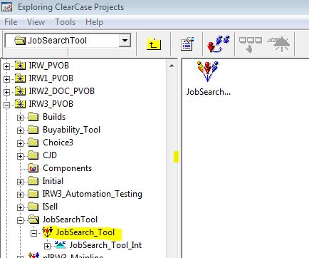

# Build

1. Open a prompt command and place where the codebase is checkouted:

U:\userid_JobSearch_Tool\IRW3\APP_JS_TOOL

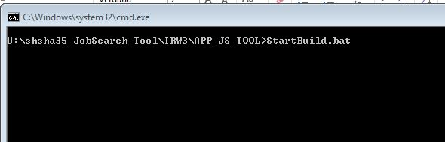

1. Before you start building the codebase be sure the JDK is installed on your machine (C:\Program Files\Java\jdk1.8.0_91\) and maven installed in the folder C:\apache-maven-3.3.3\.
2. After the command has finished check the log file in the same folder as StartBuild.bat (JSTBuild.log).

# Deployment

## Database in AWS RDS

### AWS Environment

|  |  |  |  |  |
| --- | --- | --- | --- | --- |
|  | Demo (CTE) | Staging (PPE) | Production | Comments |
| SSH Hostname | ec2-52-59-92-224.eu-central-1.compute.amazonaws.com:22 |  |  | AWS EC2 Instance Host Name |
| SSH UserName | ec2-user |  |  |  |
| SSH Password | Not Required |  |  |  |
| SSH Key File | Select location of JST_Demo.pem |  |  |  |
| MySQL Hostname | jstdemo56.citqyi5yuhh9.eu-central-1.rds.amazonaws.com |  |  |  |
| MySQL Server Port No | 3306 |  |  |  |
| Username | jstuser |  |  |  |
| Password | jstpassword |  |  |  |
| Default Schema | JST |  |  |  |

### Access RDS Database in AWS Environment

RDS database is not accessible from IKEA VDI so use the MySql outside of VDI

1. Install **MySQL Workbench 6.3 CE** using **MySQL Installer for Windows** available in **https://www.mysql.com/downloads/**
2. Open **MySQL Workbench 6.3 CE** from program menu
3. Click MySQL Connections + icon 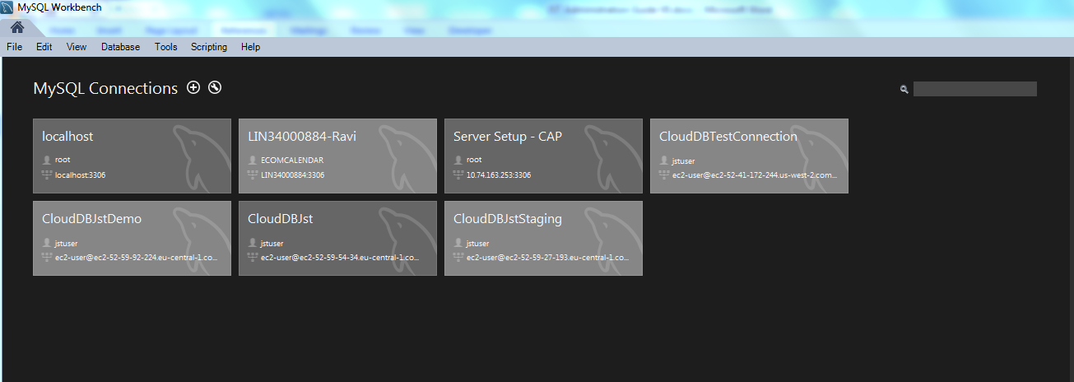
4. Select the connection method as ***Standard TCP/IP over SSH***
5. Enter the following details as per information provided in AWS Environment

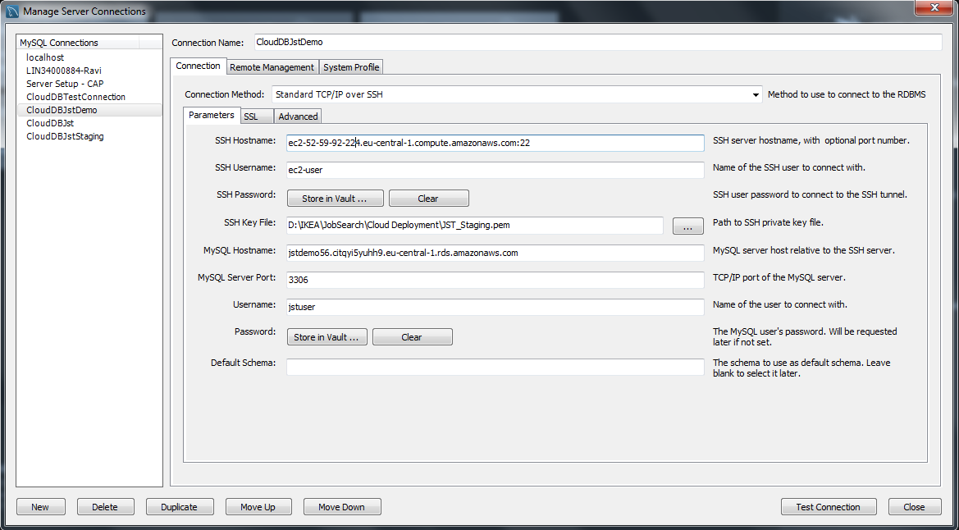

### Job Search Tool Database

Here is the data model for JST database:

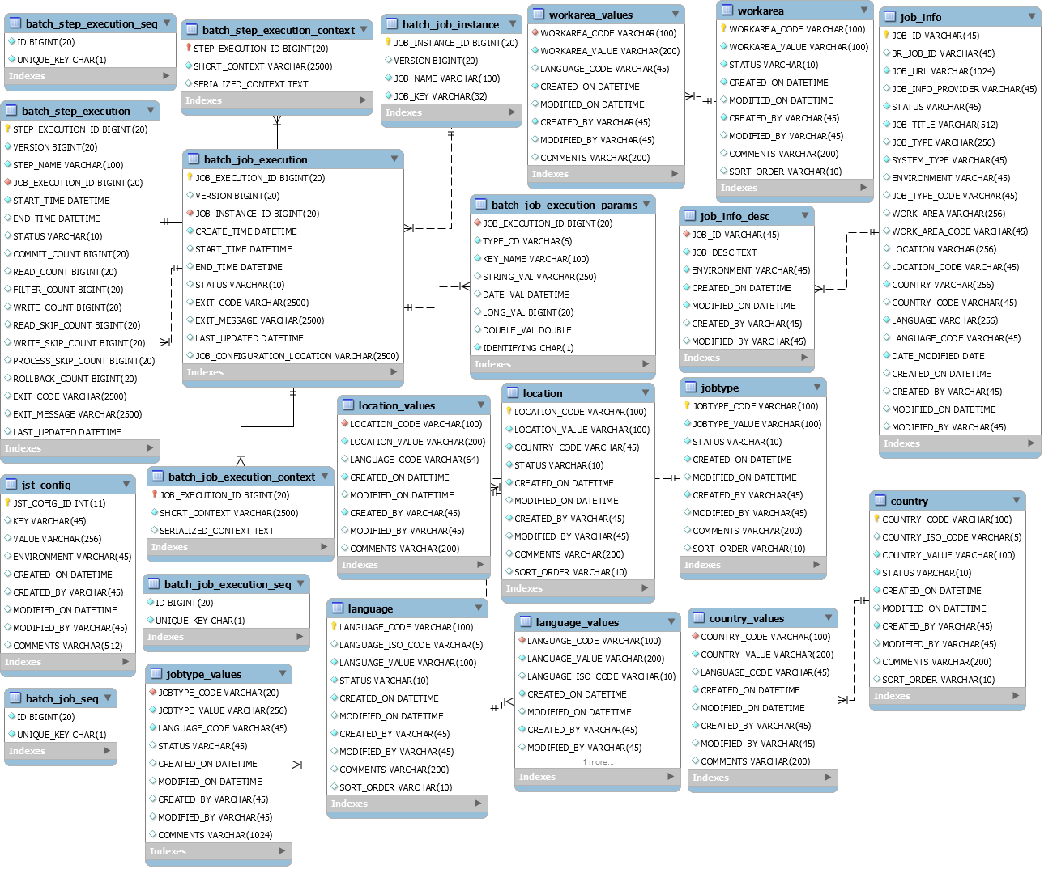

Note that DB tables: country, country_values, location, location_values, jobtype, jobtype_values, language, language_values, workarea and worarea_values are all populated by reading data from files (**BR_CONFIG_V1.xlsx** and **BR_JST_FIELDS_VALUES_V1.xlsx)** dowloaded from Amazon S3 storage

## Job Search Tool Web

### AWS Environment

|  |  |  |  |  |
| --- | --- | --- | --- | --- |
|  | Demo (CTE) | Staging (PPE) | Production | Comments |
| Linux Server Host Name (EC2 Instance ) | ec2-52-28-94-1.eu-central-1.compute.amazonaws.com |  |  |  |
| User Name | ec2-user |  |  | Can be sudo to root |
| Password | Not Required |  |  |  |
| SSH File | JST_Demo.pem |  |  |  |

### Deployment in AWS Elastic Beanstalk Environment

1. To launch a new environment open this link https://console.aws.amazon.com/elasticbeanstalk
2. From the Elastic Beanstalk console applications page, choose **Actions** for the application in which you want to launch a new environment

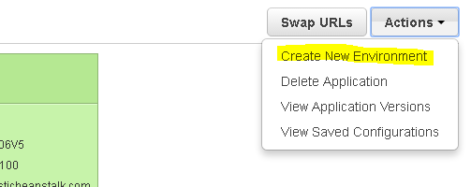

1. Choose Create New Environment and choose create web server button.
2. For **Predefined configuration**, choose the platform **Tomcat** used in our application and **Load balancing, auto scaling** environment type then click Next.
3. Select the application version and click on Next.
4. Choose an environment name and URL to be used and click Next.
5. or **Configuration Details**, set **Instance type** to t2.micro, optionally select an **EC2 key pair**, and then choose **Next**.
6. Choose **Next** to skip tag creation.
7. On the **Permissions** page, choose **Next**. If you don't have a default [instance profile and service role](http://docs.aws.amazon.com/elasticbeanstalk/latest/dg/concepts-roles.html), Elastic Beanstalk creates them for you. Then Choose **Launch**
8. To deploy the application Go to the web server you have created and click on **Upload and Deploy** button and browse your application war or zip file:

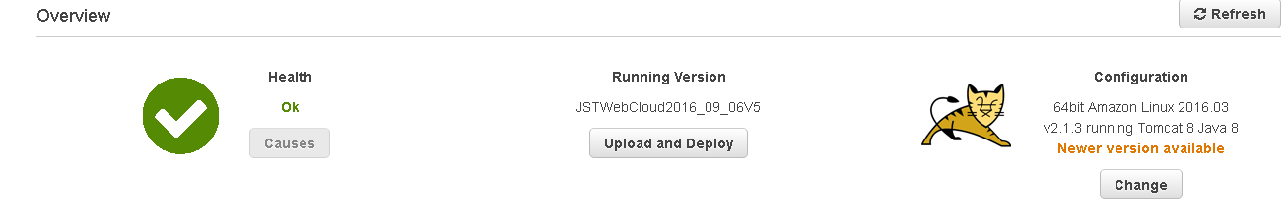

### JST application new version deployment

To deploy a new version of JST application follow steps below:

1. Open the link: https://console.aws.amazon.com/elasticbeanstalk
2. Choose an application

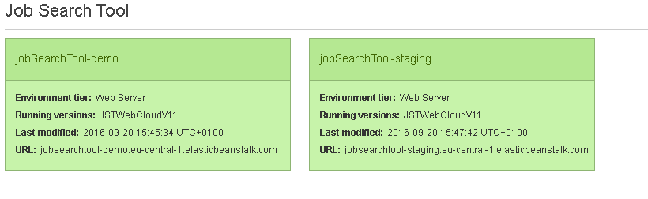

1. Click on Upload and Deploy button

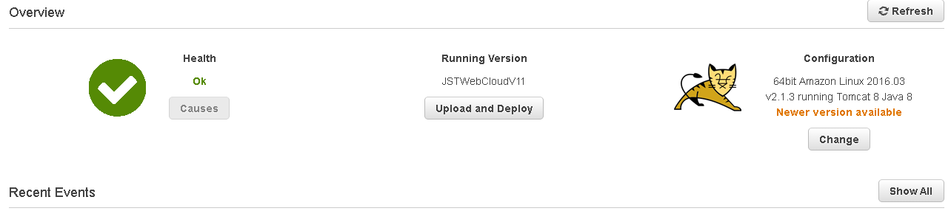

1. Choose your application and type the version label (i.e JSTWebCloudV12) then click Deploy.

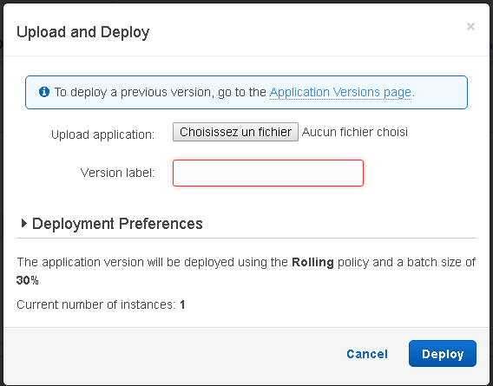

### Environment variables

1. Open the link : https://console.aws.amazon.com/elasticbeanstalk
2. Choose an application



1. After choosing an application click on Configuration in the left side as shown below

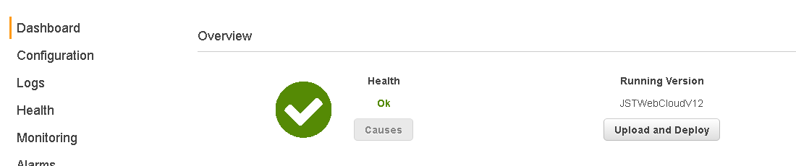

1. Click on Software configuration:

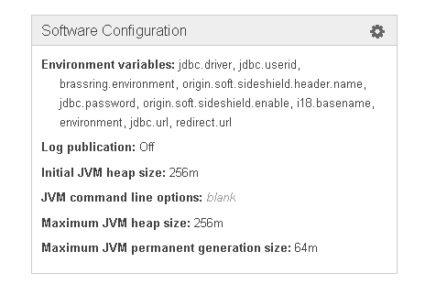

1. you will find the properties used in the application:

|  |  |
| --- | --- |
| Property name | Property value |
| brassring.environment | staging |
| environment | cte |
| i18.basename | classpath:/i18n/jstpage |
| jdbc.driver | com.mysql.jdbc.Driver |
| jdbc.password | jstpassword |
| jdbc.url | jdbc:mysql://jstdemo56.citqyi5yuhh9.eu-central-1.rds.amazonaws.com:3306/jst |
| jdbc.userid | jstuser |
| origin.soft.sideshield.enable | TRUE |
| origin.soft.sideshield.header.name | x-ikea-g2o |
| redirect.url | [http://www.cte.ikeadt.com](http://www.cte.ikeadt.com/) |

1. JDBC details retrieve them on instance you have already created(See section 4.3.3)

### JST web application logs

To get logs for JST web application follow the steps below:

1. Open the link: https://console.aws.amazon.com/elasticbeanstalk
2. Choose an application



1. After choosing the instance click Logs on the left side shown below:



1. Then click Request Logs button then select full logs

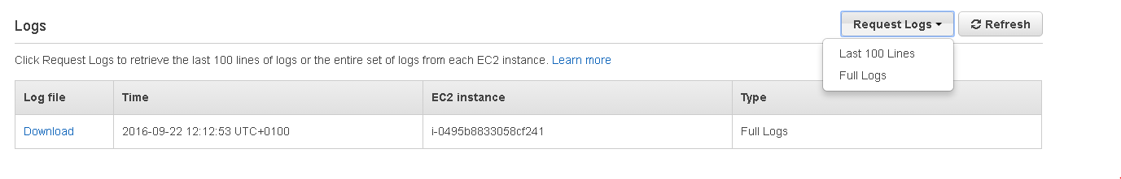

1. After that you should be able to Download link click on it and download the log files for the application.

## Job Search Tool Batch

### AWS Environment

|  |  |  |  |  |
| --- | --- | --- | --- | --- |
|  | Demo (CTE) | Staging (PPE) | Production | Comments |
| Linux Server Host Name (EC2 Instance ) | ec2-52-59-92-224.eu-central-1.compute.amazonaws.com |  |  |  |
| User Name | ec2-user |  |  | Can be sudo to root |
| Password | Not Required |  |  |  |
| SSH File | JST_Demo.ppk |  |  |  |

### Deployment in AWS Worker Environment

1. To launch a new environment open this link https://console.aws.amazon.com/elasticbeanstalk
2. From the Elastic Beanstalk console applications page, choose **Actions** for the application in which you want to launch a new environment



1. Choose Create New Environment.
2. Choose Create Worker

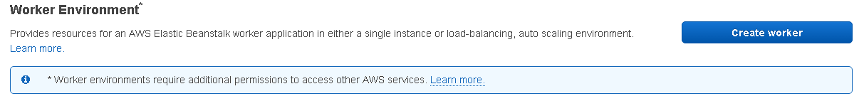

1. Choose Environment Type then click Next

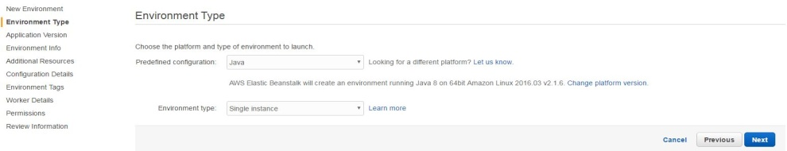

1. Then choose Application version then Next:

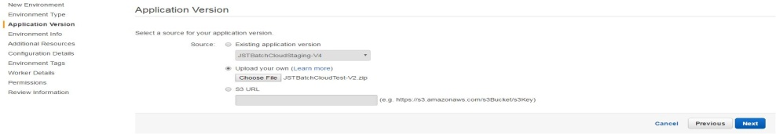

1. Choose Environment Name then Next

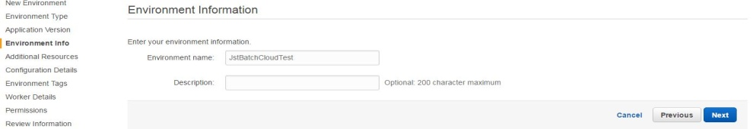

1. Use this configuration details then click Next

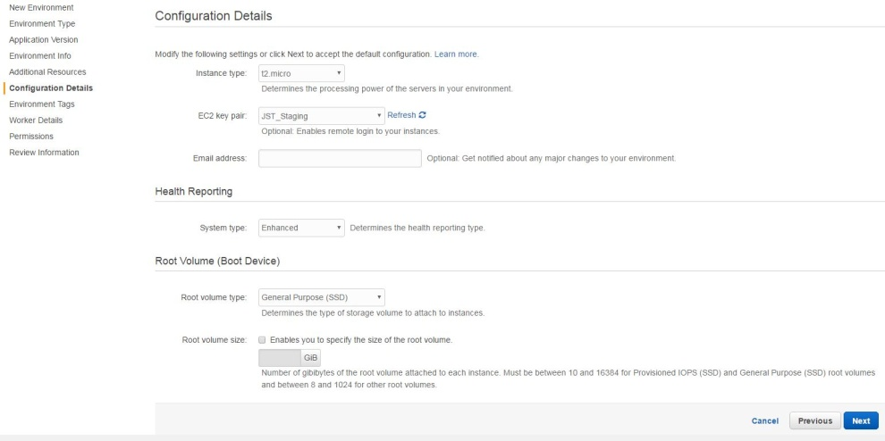

1. Use these worker details and click Next

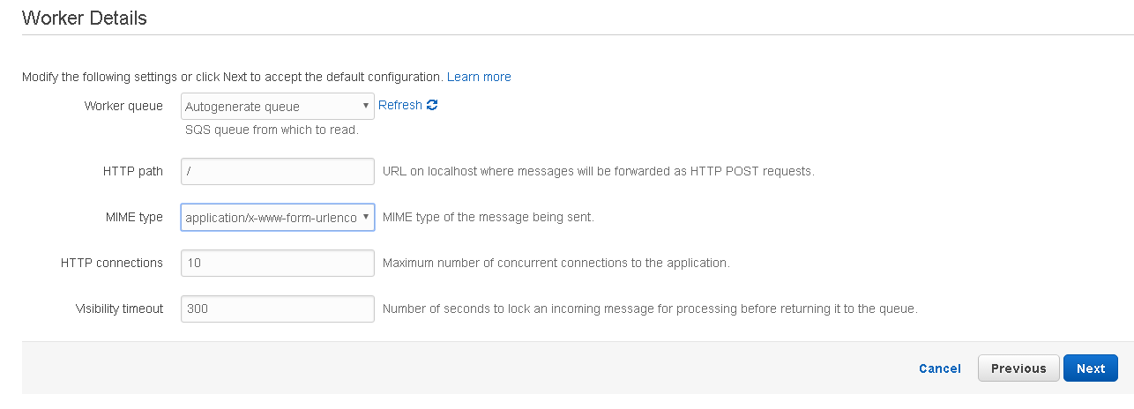

1. Click on Next then Click on Launch.
2. Go to the new environment you have created then go to Configuration software then add below properties:

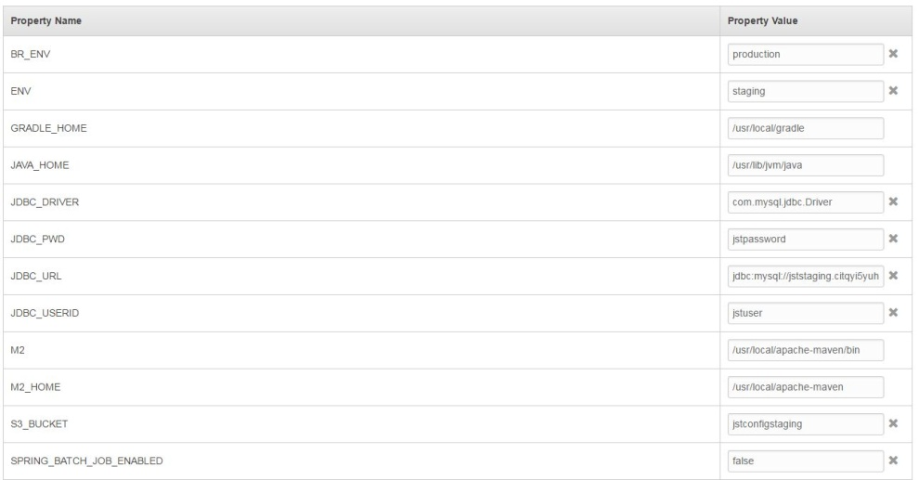

JDBC details retrieve them on instance you have already created(See section 4.3.3)

For S3_BUCKET= jstconfigstaging, it's a bucket name in amazon S3 storage where you can find config files needed by our JST batch application:

**BR_CONFIG_V1.xlsx** and **BR_JST_FIELDS_VALUES_V1.xlsx**

### Worker Scheduling

To handle scheduling jobs we use a YAML file which is in our application with the name cron.yaml.

This file contains a schedule to run the jobs periodically here's an example:

version: 1

cron:

- name: "downloadjobs-job"

url: "/downloadjobs"

schedule: "0 * * * *"

- name: "updatejobs-job"

url: "/updatejobs"

schedule: "30 * * * *"

- name: "syncfieldvalues-job"

url: "/syncfieldvalues"

schedule: "45 * * * *"

This file contains the schedule for three jobs(downloadjobs-job, updatejobs-job and syncfieldvalues)

1. Cron expression syntax:

The third field in each cron job uses a *cron expression* to define when the job should run. This expression contains five space-separated items:

minutes, hours, day of month, month and the last one day of week

1. For example the downloadjobs-job is running every hour after 30 minutes updatejobs-job will run then after 45 minutes the syncfieldvalues-job will run.

### Create instance Db in AWS:

To launch a MySQL DB instance

1. Sign in to the AWS Management Console and open the Amazon RDS console at <https://console.aws.amazon.com/rds/>.
2. In the navigation pane, click **Instances**.
3. Click **Launch DB Instance** to start the **Launch DB Instance Wizard**.

The wizard opens on the **Select Engine** page.

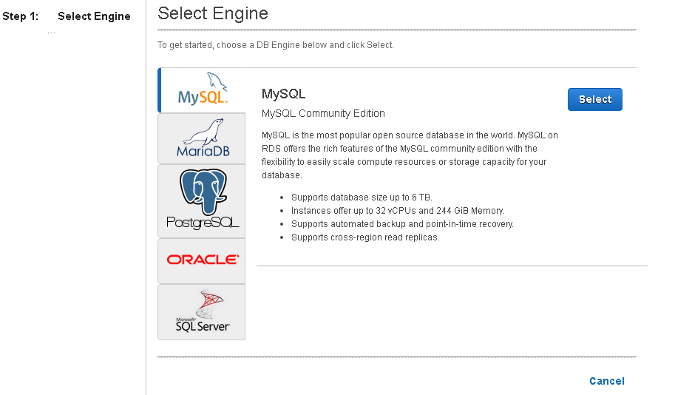

1. In the **Launch DB Instance** Wizard window, click the **Select** button for the MySQL DB engine.
2. Choose production or Dev then Next
3. Use these details for example and click Next

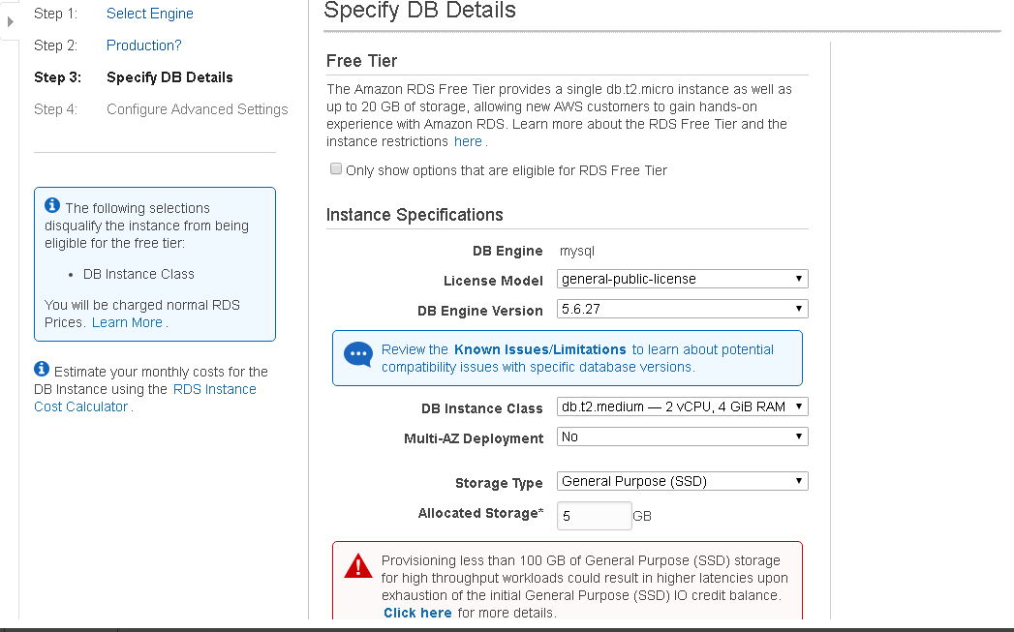

1. Then Click on Launch DB instance button

### Batch Jobs Information

JST application has three batch jobs:

1. Populating the jobs into JOB_INFO table from Brassring API
2. Updating the unposted jobs.
3. Updating the configuration data

### Automated Triggering of Batch Jobs

The batch are scheduled to automatically:

|  |  |  |
| --- | --- | --- |
| Job Name | Schedule | Comments |
| downloadjobs | Every 1 hour at 00 min | Jobs download from Brassring: (b) KB API to JST Batch |
| updatejobs | Every 1 hour at 30 min | Un posted Jobs Update:  (b) KB API to JST Batch |
| syncfieldvalues | Every 1 hour at 45 min | Update the fields only master data is available in S3:  (a) KB Excel Data to Container (Manual upload on configuration/fields update) and then JST Batch |

### Manual Triggering of Batch Jobs

1. Login to the EC2 Instance of AWS Worker Environment using Putty
2. Enter the host name as per AWS Environment

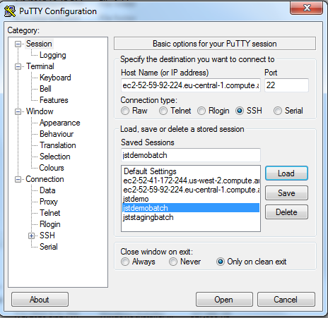

1. Select private key file as shown below

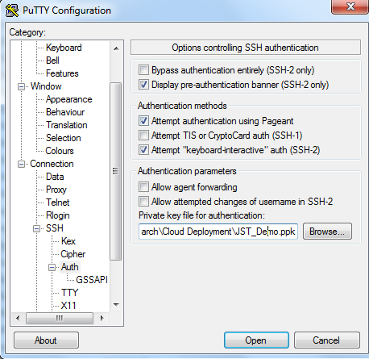

1. Enter the user name
2. Accept the ok button (if appears)

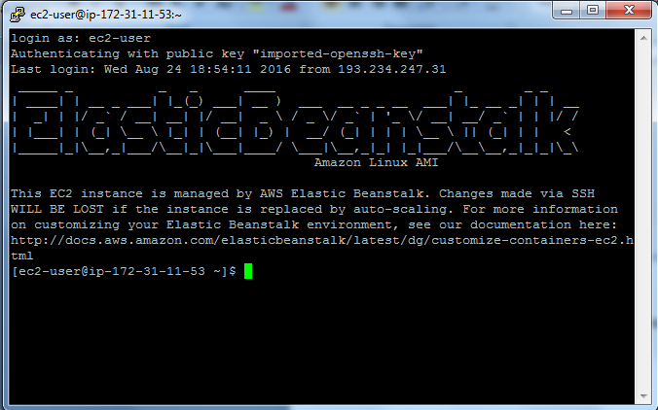

1. Enter the below command to run the jobs manually. URL values are provided in below table

wget <URL>

For Example: To run download jobs batch, execute the below command

wget http://localhost:5000/downloadjobs

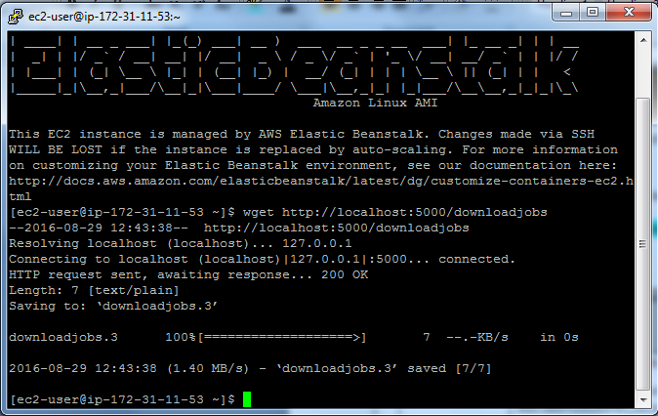

|  |  |  |  |
| --- | --- | --- | --- |
| S No | Job Description | Url  to be accessed to execute the job (URL) | Additional parameters |
| 1 | Populating the jobs from Brassring API | localhost:5000/downloadjobs  localhost:5000/downloadjobs?jobsInfoProviderName=Brassring&localesToBeProcessed=en_GB,sv_SE  localhost:5000/downloadjobs?processAllJobs=Yes | jobsInfoProviderName=brassring localesToBeProcessed=en_GB,sv_SE  (To run download for specific country)  To run download for all files |
| 2 | Updating the unposted jobs | localhost:5000/updatejobs |  |
| 3 | Updating the configuration data | localhost:5000/syncfieldvalues |  |

### Log file location for Batch jobs

To check if a batch job has successfully completed you need to check the log file located in directory **/var/log** with the name **jstbatch-1.log**

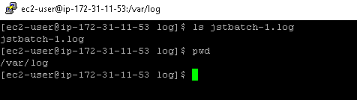

### Batch Job execution Status

To check a batch job execution status you need to run the SQL query below:

SELECT bji.JOB_NAME, bje.STATUS FROM batch_job_execution bje, batch_job_instance bji

where bje.JOB_INSTANCE_ID = bji.JOB_INSTANCE_ID

AND bji.JOB_NAME IN ('jobsInfoUpdateBatchJobId','jobsInfoPopulateBatchJobId','searchfieldsSyncBatchJobId')

order by CREATE_TIME DESC;

## New Market Addition In JST

1. In order to support a new market you need to add site ids for kenexa brassring:

You need to update the excel file BR_CONFIG_V1.xlsx in the sheet **BR_LOCALE_CONFIG** whith the values below for example:

|  |  |
| --- | --- |
| **Column** | **Value** |
| **LOCALE** | de_DE |
| **STAGING_EXTERNAL_STATUS** | ACTIVE |
| **STATGING_EXTERNAL_SITE_ID** | 5184 |
| **STAGING_INTERNAL_STATUS** | 6032 |
| **PRODUCTION_STATUS** | ACTIVE |
| **PRODUCTION_EXTERNAL_SITE_ID** | 5041 |
| **PRODUCTION_INTERNAL_SITE_ID** | 5047 |
| **SITE_LOCALE_ID** | 1031 |
| **BR_LANG_ID** | 23 |
| **LANGUAGE** | German |
| **ISO_STATE_CODE** | de |
| **DATE_FORMAT** | dd/MM/yyyy |

1. You need also to create an internalization properties file for the market example(Refer to section 4.6):

jstpage_de_DE.properties which contains a set o f key, values used in JST web pages.

### 

### Master Field Values Update

1. In order to update master field values you need to update the excel file BR_JST_FIELDS_VALUES_V1.xlsx which contains the values for search fields like country, location, workarea, job type and language
2. You need to update all sheets with appropriate data in the excel file: Country, Location, Workarea, Job Type, Language and Country Location Map.

### Supported Countries and Languages

|  |  |  |  |  |
| --- | --- | --- | --- | --- |
| **Market Name** | **Language** | **Language Code** | **Country Code** | **URL** |
| **Belgium** | ***Dutch (NL)*** | nl | BE | [ww8.cte.ikeadt.com/ext/job/search/external/be/nl/home](http://www.ikea.com/ext/job/search/external/be/nl/home) |
| **Belgium** | ***French (FR)*** | fr | BE | [ww8.cte.ikeadt.com/ext/job/search/external/be/fr/home](http://www.ikea.com/ext/job/search/external/be/fr/home) |
| **Czech Republic** | ***Czech*** | cs | CZ | [ww8.cte.ikeadt.com/ext/job/search/external/cz/cs/home](http://www.ikea.com/ext/job/search/external/cz/cs/home) |
| **Denmark** | ***Danish*** | da | DK | [ww8.cte.ikeadt.com/ext/job/search/external/dk/da/home](http://www.ikea.com/ext/job/search/external/dk/da/home) |
| **Germany** | ***German*** | de | DE | [ww8.cte.ikeadt.com/ext/job/search/external/de/de/home](http://www.ikea.com/ext/job/search/external/de/de/home) |
| **Austria** | ***German*** | de | AT | [ww8.cte.ikeadt.com/ext/job/search/external/at/de/home](http://www.ikea.com/ext/job/search/external/at/de/home) |
| **Switzerland** | ***German*** | de | CH | [ww8.cte.ikeadt.com/ext/job/search/external/ch/de/home](http://www.ikea.com/ext/job/search/external/ch/de/home) |
| **Switzerland** | ***French (FR)*** | fr | CH | [ww8.cte.ikeadt.com/ext/job/search/external/ch/fr/home](http://www.ikea.com/ext/job/search/external/ch/fr/home) |
| **Switzerland** | ***Italian (IT)*** | it | CH | [ww8.cte.ikeadt.com/ext/job/search/external/ch/it/home](http://www.ikea.com/ext/job/search/external/ch/it/home) |
| **Italy** | ***Italian (IT)*** | it | IT | [ww8.cte.ikeadt.com/ext/job/search/external/it/it/home](http://www.ikea.com/ext/job/search/external/nl/home) |
| **Spain** | ***Spanish (ES)*** | es | ES | [ww8.cte.ikeadt.com/ext/job/search/external/es/es/home](http://www.ikea.com/ext/job/search/external/nl/home) |
| **France** | ***French (FR)*** | fr | FR | [ww8.cte.ikeadt.com/ext/job/search/external/fr/fr/home](http://www.ikea.com/ext/job/search/external/nl/home) |
| **Croatia** | ***Croatian*** | hr | HR | [ww8.cte.ikeadt.com/ext/job/search/external/hr/hr/home](http://www.ikea.com/ext/job/search/external/nl/home) |
| **Hungary** | ***Hungarian*** | hu | HU | [ww8.cte.ikeadt.com/ext/job/search/external/hu/hu/home](http://www.ikea.com/ext/job/search/external/nl/home) |
| **Netherland** | ***Dutch (NL)*** | nl | NL | [ww8.cte.ikeadt.com/ext/job/search/external/nl/nl/home](http://www.ikea.com/ext/job/search/external/nl/home) |
| **Norway** | ***Norwegian*** | no | NO | [ww8.cte.ikeadt.com/ext/job/search/external/no/no/home](http://www.ikea.com/ext/job/search/external/nl/home) |
| **Poland** | ***Polish*** | pl | PL | [ww8.cte.ikeadt.com/ext/job/search/external/pl/pl/home](http://www.ikea.com/ext/job/search/external/nl/home) |
| **Portugal** | ***Portuguese*** | pt | PT | [ww8.cte.ikeadt.com/ext/job/search/external/pt/pt/home](http://www.ikea.com/ext/job/search/external/nl/home) |
| **Romania** | ***Romanian*** | ro | RO | [ww8.cte.ikeadt.com/ext/job/search/external/ro/ro/home](http://www.ikea.com/ext/job/search/external/nl/home) |
| **Russia** | ***Russian*** | ru | RU | [ww8.cte.ikeadt.com/ext/job/search/external/ru/ru/home](http://www.ikea.com/ext/job/search/external/nl/home) |
| **Slovakia** | ***Slovak*** | sk | SK | [ww8.cte.ikeadt.com/ext/job/search/external/sk/sk/home](http://www.ikea.com/ext/job/search/external/nl/home) |
| **Serbia** | ***Serbian*** | sr | RS | [ww8.cte.ikeadt.com/ext/job/search/external/rs/sr/home](http://www.ikea.com/ext/job/search/external/nl/home) |
| **Finland** | ***Finnish*** | fi | FI | [ww8.cte.ikeadt.com/ext/job/search/external/fi/fi/home](http://www.ikea.com/ext/job/search/external/nl/home) |
| **Sweden** | ***Swedish(SV)*** | sv | SE | [ww8.cte.ikeadt.com/ext/job/search/external/se/sv/home](http://www.ikea.com/ext/job/search/external/nl/home) |
| **United States** | ***English*** | en | US | [ww8.cte.ikeadt.com/ext/job/search/external/us/en/home](http://www.ikea.com/ext/job/search/external/nl/home) |
| **Australia** | ***English*** | en | AU | [ww8.cte.ikeadt.com/ext/job/search/external/au/en/home](http://www.ikea.com/ext/job/search/external/nl/home) |
| **Ireland** | ***English*** | en | IE | [ww8.cte.ikeadt.com/ext/job/search/external/ie/en/home](http://www.ikea.com/ext/job/search/external/nl/home) |
| **United Kingdom** | ***English*** | en | GB | [ww8.cte.ikeadt.com/ext/job/search/external/gb/en/home](http://www.ikea.com/ext/job/search/external/nl/home) |
| **Canada** | ***English*** | en | CA | [ww8.cte.ikeadt.com/ext/job/search/external/ca/en/home](http://www.ikea.com/ext/job/search/external/nl/home) |
| **Canada** | ***French (FR)*** | fr | CA | [ww8.cte.ikeadt.com/ext/job/search/external/ca/fr/home](http://www.ikea.com/ext/job/search/external/nl/home) |
| **China** | ***English*** | en | CN | [ww8.cte.ikeadt.com/ext/job/search/external/cn/en/home](http://www.ikea.com/ext/job/search/external/nl/home) |
| **China** | ***Chinese*** | zh | CN | [ww8.cte.ikeadt.com/ext/job/search/external/cn/zh/home](http://www.ikea.com/ext/job/search/external/nl/home) |
| **India** | ***English*** | en | IN | [ww8.cte.ikeadt.com/ext/job/search/external/in/en/home](http://www.ikea.com/ext/job/search/external/nl/home) |
| **Japan** | ***English*** | en | JP | [ww8.cte.ikeadt.com/ext/job/search/external/jp/en/home](http://www.ikea.com/ext/job/search/external/nl/home) |
| **Japan** | ***Japanese*** | ja | JP | [ww8.cte.ikeadt.com/ext/job/search/external/jp/ja/home](http://www.ikea.com/ext/job/search/external/nl/home) |
| **Malaysia** | ***English*** | en | MY | [ww8.cte.ikeadt.com/ext/job/search/external/my/en/home](http://www.ikea.com/ext/job/search/external/nl/home) |
| **Malaysia** | ***Malaysian*** | ms | MY | [ww8.cte.ikeadt.com/ext/job/search/external/my/ms/home](http://www.ikea.com/ext/job/search/external/nl/home) |
| **Singapore** | ***English*** | en | SG | [ww8.cte.ikeadt.com/ext/job/search/external/sg/en/home](http://www.ikea.com/ext/job/search/external/nl/home) |
| **South Korea** | ***English*** | en | KR | [ww8.cte.ikeadt.com/ext/job/search/external/kr/en/home](http://www.ikea.com/ext/job/search/external/nl/home) |
| **South Korea** | ***Korean*** | ko | KR | [ww8.cte.ikeadt.com/ext/job/search/external/kr/ko/home](http://www.ikea.com/ext/job/search/external/nl/home) |
| **Thailand** | ***English*** | en | TH | [ww8.cte.ikeadt.com/ext/job/search/external/th/en/home](http://www.ikea.com/ext/job/search/external/nl/home) |
| **Thailand** | ***Thai*** | th | TH | [ww8.cte.ikeadt.com/ext/job/search/external/th/th/home](http://www.ikea.com/ext/job/search/external/nl/home) |

## Job Search Tool integration in IRW:

### Job Search Tool in IRW HR Landing Page:

All links have to be updated in Teamsite to use new JST links.

## How to generate property file

### Property File Generator Tool

Download the tool to local drive on your computer.



### Tool Layout

** Tab**

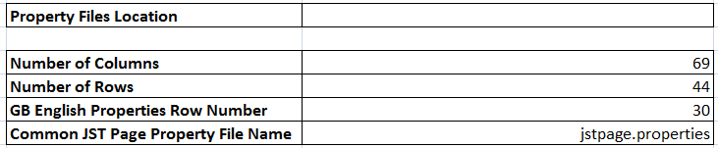

**Property Files Location**, This is the location (Directory) where Property Files for all locales will be generated. Please specify the directory name in following format

If the property files have to be generated under Sub Directory Property Files in Directory Job Search Tool in D Drive of your computer then enter the following value for **Property Files Location**

D:\Job Search Tool\Property Files

**Number of Columns** is the total number of Columns used in  tab of the tool.

(The last column used is BQ which is the property key dummy for link)

**Number of Rows** is the total number of Rows filled in  tab of the tool.

(The last row used is 44 which is the property key row for Thailand in Thai)

Please do not forget to update the Number of Columns if a new key is added

Or

Update the Number of Rows if any new Locale is added

**GB English Properties Row Number** is the row in  tab where property key content is provided in English, this is required because if the translated text is not available for any locale, the content from corresponding key in English is used.

**Common JST Page Property File Name**, this is used to generate jstpage.properties file, this file is used as a fall back property file if the Properties file is not available for any locale in Job Search Tool that is configured.

### Generate Property Files

Before generating the property files follow the steps mentioned below to get the latest content / translations

1. Delete existing contents in JST_Matrix tab of Property File Generator Tool spread sheet (E3 : BM44)

Open JST_Content_Key_Value_v1.6.xlsx file from Project Place

<https://service.projectplace.com/pp/pp.cgi/r1258793682>

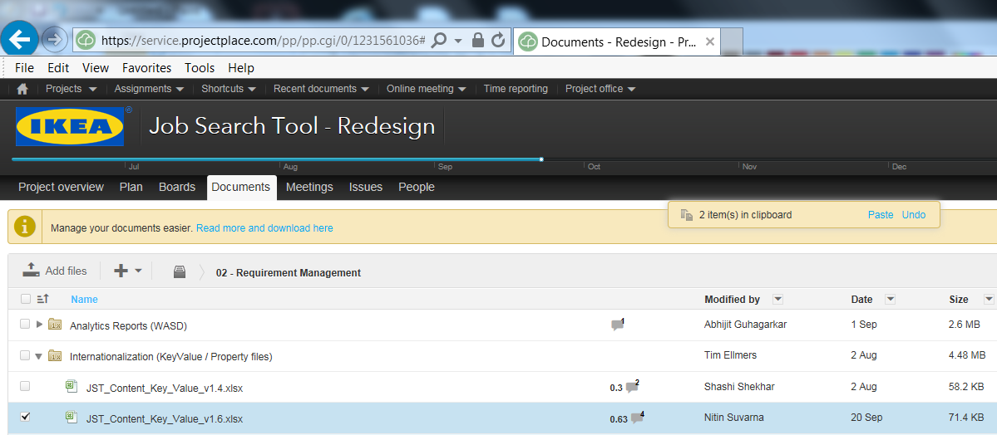

1. Copy Contents from JST_Matrix tab (E3 : BM44)

from JST_Content_Key_Value_v1.6.xlsx file in Project Place

to JST_Matrix tab (E3 : BM44) in Property File Generator Tool.

1. To copy the translations for Search Engine Optimization and Meta

Copy Contents from SEO -Meta Desc, Keyword & Title tab (D3 : F44)

from JST_Content_Key_Value_v1.6.xlsx file in Project Place

to JST_Matrix tab (BN3 : BP44) in Property File Generator Tool.

1. Copy Contents from JST_Matrix tab (BN3 : BN44)

from JST_Content_Key_Value_v1.6.xlsx file in Project Place

to JST_Matrix tab (BQ3 : BQ44) in Property File Generator Tool.

Click  button in  tab to generate the Property Files.